diagbox7.01软件问题 diagbox7.01 software problems

客户在安装diagbox7.01软件之后，有部分车型不能测试，那是因为软件在运行的过程中把硬件版本强制升级了，导致部分车型不能测试使用。Client software after installing diagbox7.01, some models can not be tested, it is because the process of software running forced to upgrade the hardware version, resulting in some models can not test use.
你只需要把光盘里面的You just need to install the CD inside this document 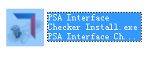这个文件安装install the CD inside this document，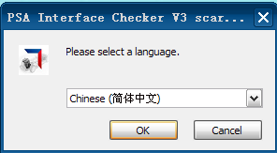 安装完成之后运行这个图标Run the icon after the installation is complete 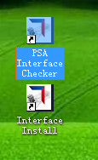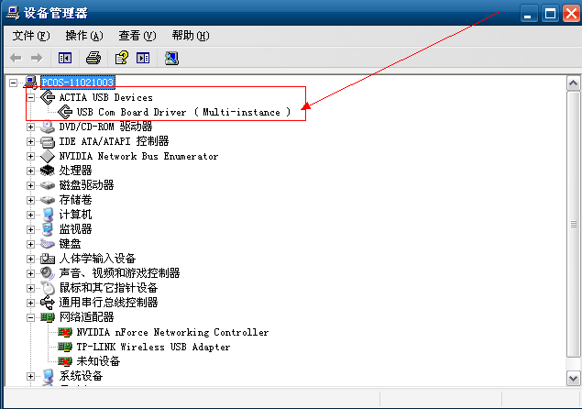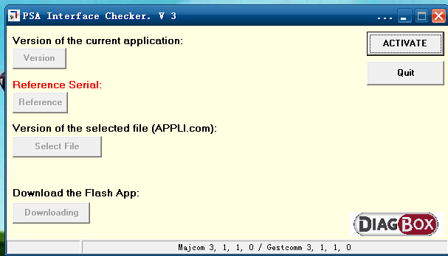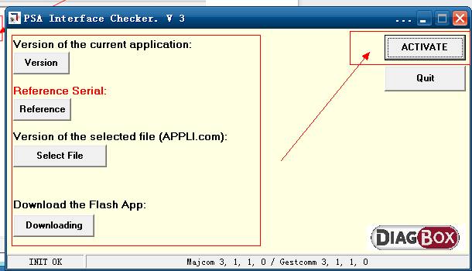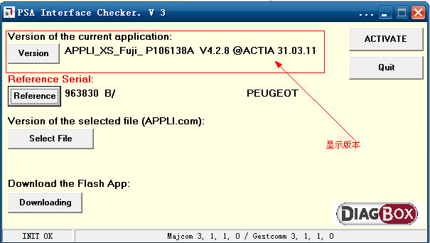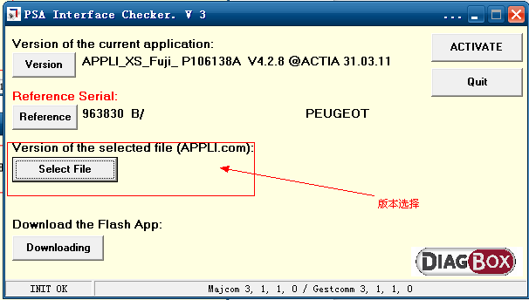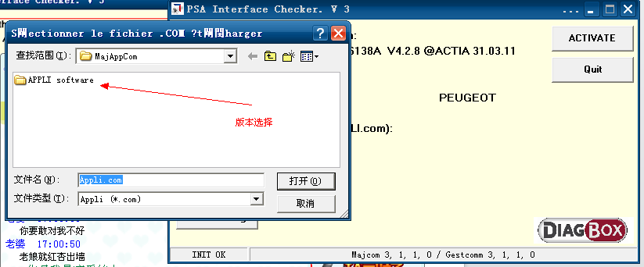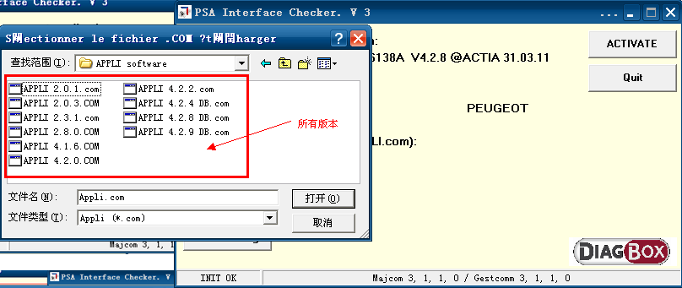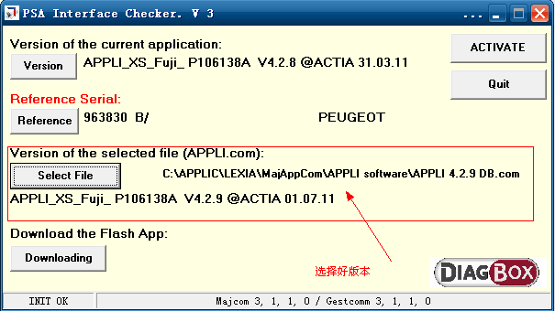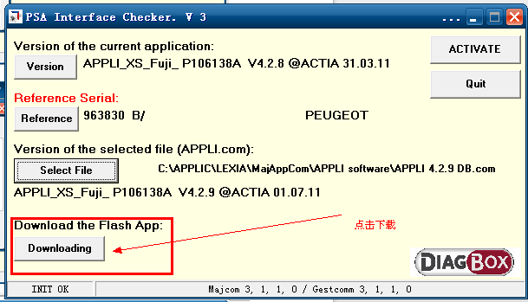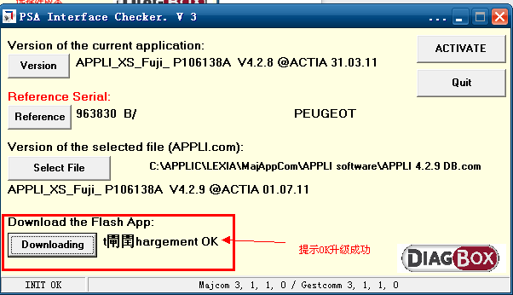

然后重新插拔在打开软件查看版本Then re-plug view the version in the Open Software 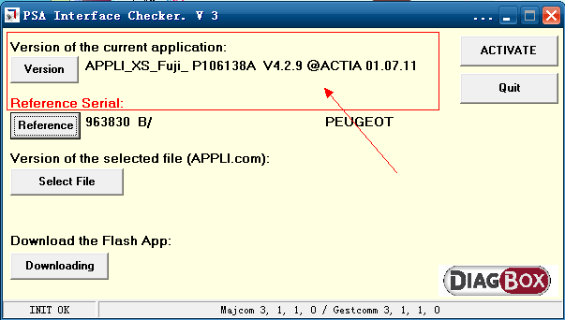
这样就可以去测试车型了，测试车型的时候提示这个This allows to test vehicles, the test vehicle when prompted this 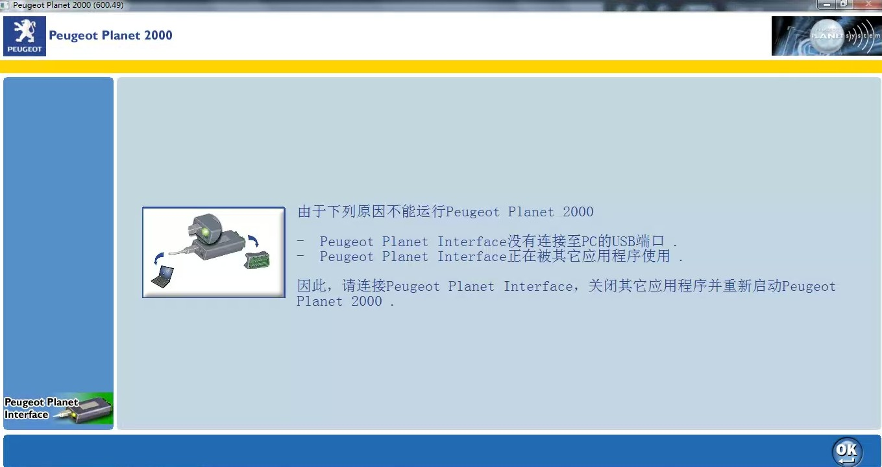重新插拔一下USB在测试，就可以成功进入测试界面。Reseated USB testing, we can successfully enter the test interface.

