安装虚拟光驱Install virtual drive 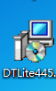
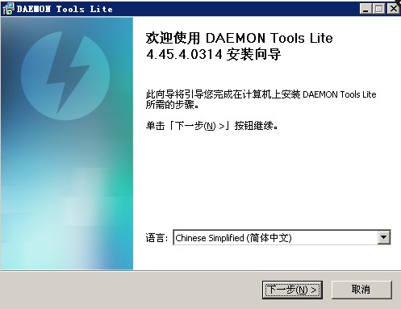
点击下一步，免费许可Click Next, royalty-free license
只勾选Just check 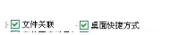
然后下一步，安装完成，不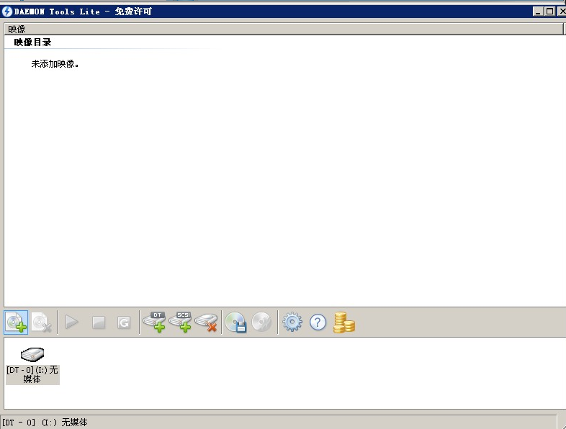
右击添加映象，选择光盘diagbox里面7.01的内容 Then the next step, the installation is complete, the image is not right-click Add, select the contents of the disc diagbox inside 7.01
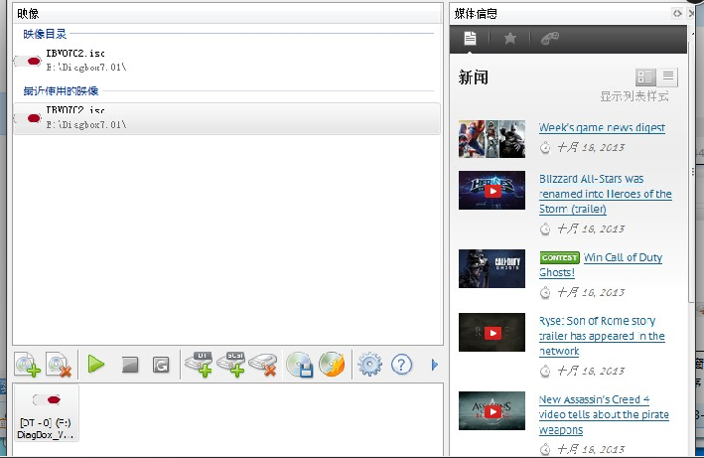
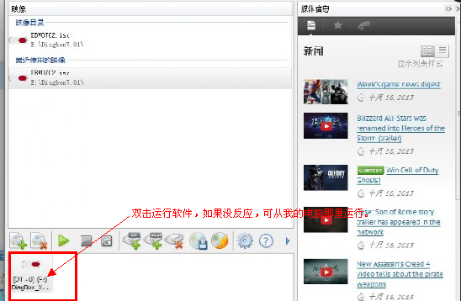 Double-click to run the software ，if no answer , choose from my computer run it .
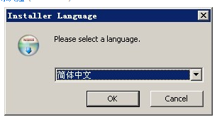选择简体中文进行安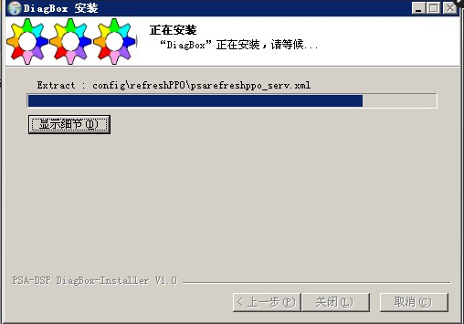
安装完成后在桌面生成图标，软件也会自动运行，如果没有运行，也可手动运行桌面图标。After the installation is complete generation desktop icon, the software will automatically run, if not running, you can manually run the desktop icon.
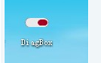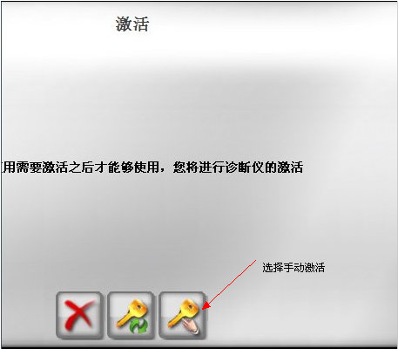选择scary01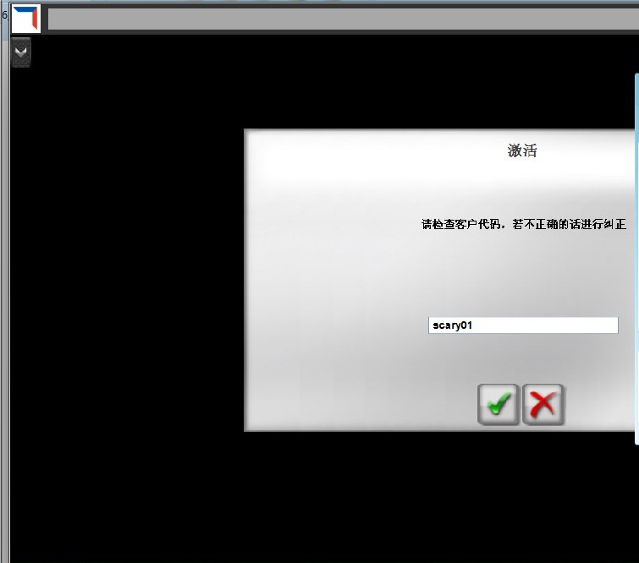
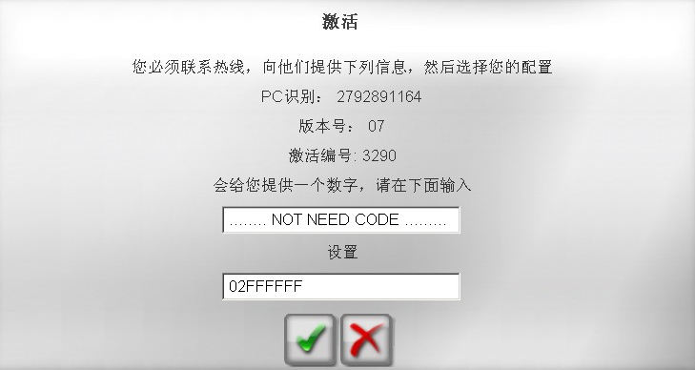
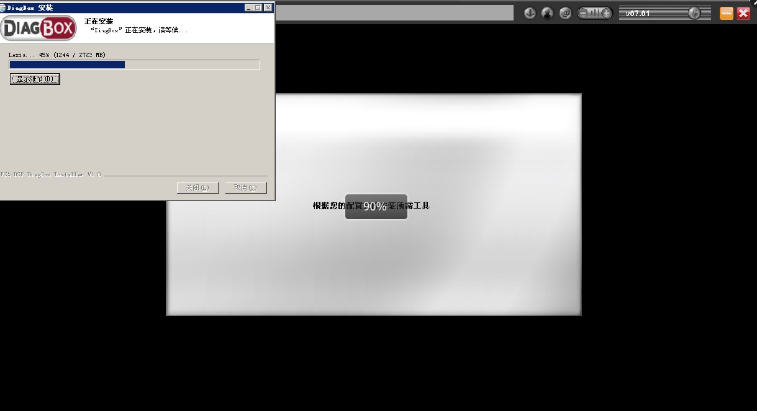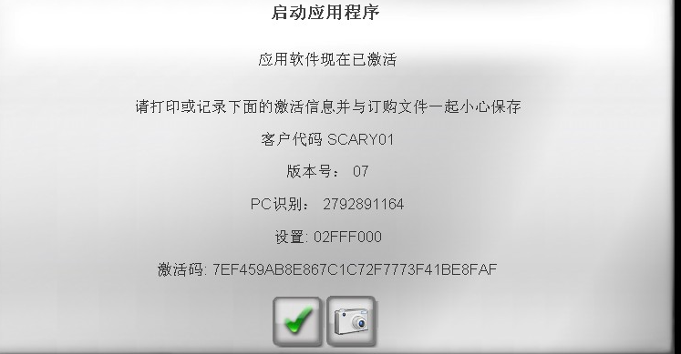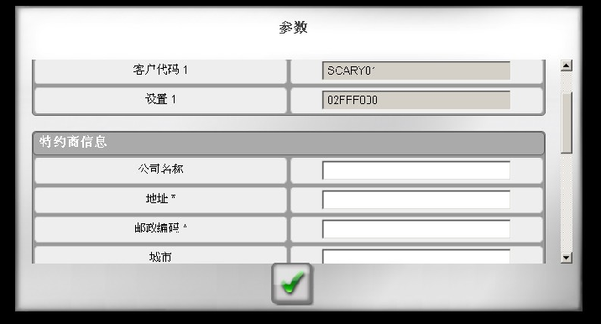
填写*号的内容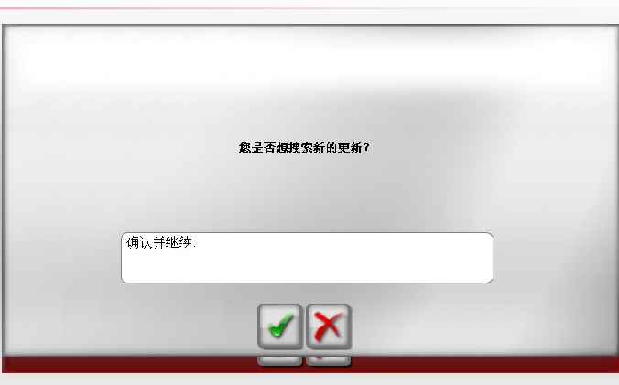
选择x 不更新，完成 Select x is not updated, complete

